**While vs. Do While**

**Obj. & Classes**

**User Defined**

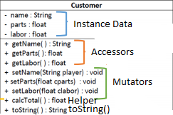

* Constructor(s) not listed
* Return acc., helper & toString

**Arrays**  
// Iterating through myArray  
for (i = 0; i < myArray.length; ++i) {  
   // Loop body accessing myArray[i]  
}

**GUIs**

**File Scanning**

File file = new File("file.txt”);

**Security Coding**

**Clean Code**

**Encryption**